Goin’ Rogue Games Rules

**This is a living document that will be available for the public to review. Changes will be made as needed by Jeremy Futrell, owner of Goin’ Rogue LLC., or his designee.**

**The purpose of this rule set is to give judges, competitors, and the public a detailed understanding of events and rules at games run by Goin’ Rogue.**

**We recognize that all games are individual and may have different conditions based on field, turf, weather, crowd and other factors. The athletic director may make changes on the day without advanced notice to accommodate individual differences, however every reasonable accommodation will be made to not do so, or to inform athletes and judges ahead of time. A printed copy will be available at every game when feasible.**

**While we welcome input and opinions please respect this is how we shall run our games, not your games. That being said you can always reach us or ask questions, email: *podcastgoinrogue@gmail.com***

## Table of Contents

Pg 3 - General Rules for All Events

Pg 6 - General Rules for Distance Events

Pg 8 - Stone Puts

Pg 9 - Weights for Distance

Pg 10 - Hammers

Pg 11 - Caber

Pg 14 - General Rules for Height Events

Pg 15 - Sheaf Toss

Pg 16 - Weight Over Bar/Weight For Height

Pg 17 - Judges

* **General Rules for All Events**

1. The Athletic Director has the final say on all matters involving the games under his/her direction to include events contested, flights, groupings, rotations, and rules of the day; such as allowing or disallowing spinning height attempts. Athletic Directors will ensure the events are completed following the general rule set as outlined.
2. A Scottish Heavy Events competition is defined by at least five of the events listed. If only five events are used, then no two events will be similar (such as two stones, two weight throws for distance, or two hammers).
3. If an implement breaks during a competition and cannot be repaired quickly, the round in which it broke should be started over with a new implement being used. If the judge determines that time does not allow for this, then a new implement will be used and the round continues where it left off.
4. In the interest of safety, the judge has the right to disqualify any competitors who in their opinion do not have the ability to complete a throw without injuring themselves, other competitors or spectators. The judge also has the right to disqualify any competitors who display poor sportsmanship or intoxication from any substance/agent.
5. All competitors competing shall wear a kilt during the competition or at the discretion of the Athletic Director.
6. The judge may apply a time limit to each throw (no less than 60 seconds) if he feels it is necessary. If the competitor does not begin the throw within this time limit the attempt will be a foul.
7. In the event of a tie after any of the above tie-breaking methods have been applied, the points for the places in question will be added together and divided evenly among the tied competitors.
8. The trig will be 4'-6" long, 6" tall, and 6" wide. Every effort shall be made to secure the trig to the ground so that it will not move during the event if a competitor steps against it. The wings (if using winged trig) shall also be secured to the trig and/or ground. Wings shall be 18” long and extend at an approximate 45-degree angle to complete the 6’9” extended box.
9. The winner of the event may take three extra throws to try to break a record, whether it be a Games Record, North American Record, or World Record. Extra throws taken for records will not count for points in the decathlon scoring system.
10. Individual fingers or the thumb of the throwing hand may be taped but the fingers or thumb will not be taped together. No straps or other devices besides a glove will be used to aid the competitor in holding the implement. No footwear that may aid in increasing the athlete's height will be used in the events thrown for height. Final say on what constitutes “increasing height” is left to the athletic director.
11. For a competitor to win or place in an overall competition, they must attempt to compete in all the events. At the discretion of the judge, if the competitor does not attempt to compete in all the events, then they will not receive points or awards for the individual events or the overall competition.
12. The points for an event are as follows: The winner of each event receives 1 point, second receives 2, and so on. The overall score is determined by adding the event points per athlete, least number of points total wins the competition.
13. Measurements shall be recorded after rounding the measurement down to the nearest 1/4" in all the events.
14. **Drop order.** After each completed event, the competitor who threw first is now placed last in the next event and all other competitors move up one place. This is repeated after every event.
15. When an American, North American, or World Record has been broken it is the responsibility of the Athletic Director to verify that record. The Record must be set within all rules for that event. The implement will be weighed on a certified scale and the weight will be equal to or more than the legal weight for that implement. In the case of the Weights for Distance, the Weight for Height, and the Hammer Throw, the overall length of the implement will be measured, and the length will be equal to or less than the legal length of that implement.
16. American records must be set by a competitor with American citizenship and may be set anywhere in the world. Canadian records must be set by a competitor with Canadian citizenship and may be set anywhere in the world. North American records must be set by a competitor with citizenship in North America and may be set anywhere in the world. World records may be set by any competitor anywhere in the world.
17. Safety must be a paramount concern to all the organizers, judges, competitors, helpers, and spectators present at the competition. Precautions should be taken to protect these people. The throwing area should be roped off to keep spectators off the athletic field. There should be some type of cage or backstop for the hammer throw.
18. If the judge has a doubt about calling a foul on a competitor, then no foul should be called. The benefit of the doubt should always go to the athlete.
19. Chalk and tacky may be used in every event unless it poses a safety risk outlined by the AD or Judge. Support gear may be worn throughout. Such as, but not limited to: neoprene belts, elbow and knee sleeves, and wrist wraps. Braces may be worn as long as the clear and intended purpose is to support the competitor. Nothing may be worn that provides a clear and unfair mechanical advantage on it’s own, this decision is made on a case by case basis by the athletic director if it is brought to their attention. If you have questions, ask.
20. If the overall score ends in a tie, the following method should be used to break the tie and determine a winner:
    1. The athlete who has the most 1st place finishes breaks the tie.
    2. If a tie remains, the most 2nd place finishes are counted.
    3. If a tie remains, the most 3rd place finishes are counted.
    4. If a tie remains, the winner of caber between the two athletes breaks the tie.
    5. If a tie remains, the Athletic Director may decide a play off event which can be one throw or three throws at the discretion of the Athletic Director. Caber is preferred however if a suitable caber is not available the athletes who are tied may agree to a throw-off with any of the remaining events. If no agreement can be reached, the Athletic Director may choose between the two suggested events by a flip of the coin.

* **General Rules for Distance Events**

1. A **backline** shall be drawn the appropriate distance from and parallel to the trig. The distance shall be 7’6” from the trig for Stone Puts and 9’0” from the trig for the Weight for Distance events.
2. Sidelines are defined by visible lines from the edges of the trig to the backline.
3. The competitor will complete the throw **under control** as decided by the judge or the throw will be ruled a foul. The competitor shall remain behind the trig and in bounds upon completion of the throw.
4. Each competitor will be allowed three throws in the competition, the farthest of which will count for that event. **Extras** will be allowed at the discretion of the judge for the winner of each event to attempt to set new personal, field or world records. Three extra throws are allowed.
5. The competitor may stop during the throw and **restart** the throw if no foul has occurred. The competitor may even leave the throwing area before restarting if allowed by the judge.
6. Each throw will be **measured** from a point on the inside-upper edge of the trig closest to where the competitor's plant foot (left foot for a right-handed competitor) landed to the nearest break in the ground made by the implement (not including the handle).
7. **Ties** will be broken by comparing the next farthest throw for each competitor involved in the tie. The competitor with the farthest of these throws will place highest. If other ties occur, then this process will repeat for all attempts taken.
8. A throw will be a **foul** if the competitor touches any surface of the trig other than the edge facing the throwing area.
9. **Traditional** trigs; One of the competitor's feet must always remain in the throwing area either on the ground or in space directly above the throwing area. The competitor may have one foot out to the left or right of the sidelines. No part of the competitor may touch the ground in front of the trig or behind the backline irrespective of left or right of the throwing area. See diagram below.
10. **Winged** trigs; both feet must stay inside all lines until completion of the throw.
11. All **trigs**, standard or winged, will be based off the 4’6” trig. See diagrams below.
12. **Extra throws** may be awarded to the victor of each event at the discretion of the judge or Athletic Director to break personal records or established records. The judge or Athletic Director may terminate the extra throws if the athlete fails to throw farther than the last competition throw. The athlete can also choose to terminate the extra throws at any point.

**Standard trig Winged trig**

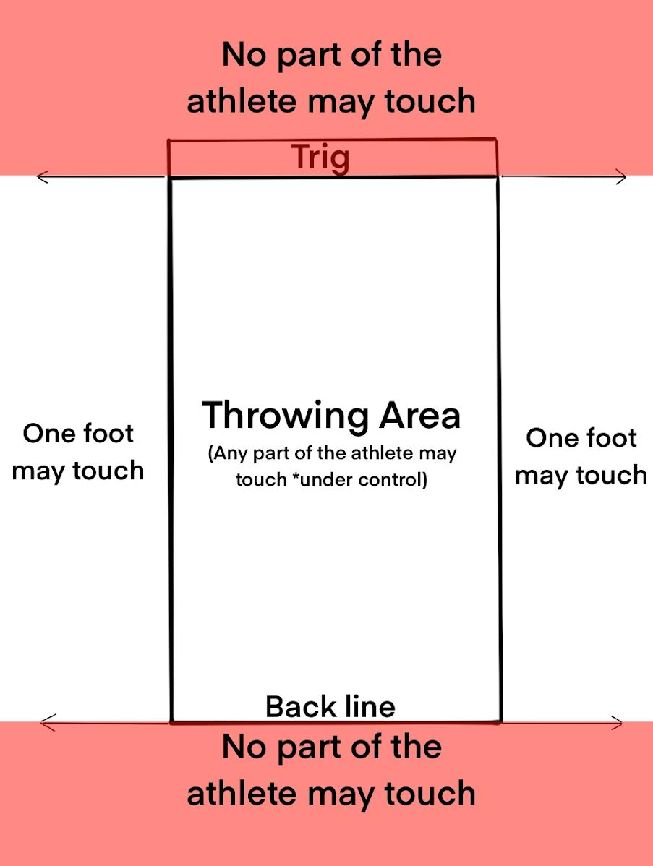 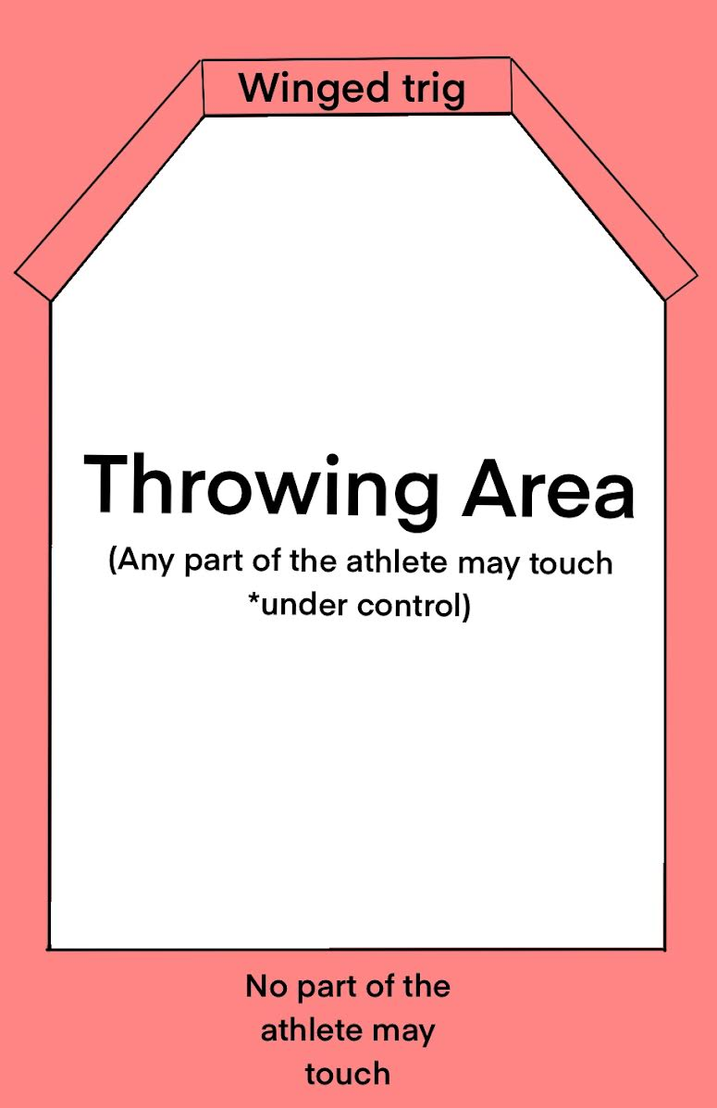

* **Stone Puts**

There is no standard size of the stone, only a range of weight. The stone shall be put with one hand. The stone shall remain against the neck throughout the throw until the release.

1. **Open Stone**

Standard weight for *men*: **16lbs. to 22lbs.**

Standard weight for *women*: **8lbs. to 12lbs.**

Any throwing style may be used as long as the rules of the trig are followed, and the style is deemed safe by the judge.

The backline will be drawn 7'-6" from the trig.

1. **Braemar Stone**

Standard weight for men: **20lbs. to 26lbs.**

Standard weight for women: **12lbs. to 18lbs.**

No approach allowed. The stone must be put from a standing position. Reversing the feet after the release is allowed. **Lifting of the lead foot** is allowed if there is no advancement of said foot during throw.

The backline will be drawn 7'-6" from the trig.

* **Weights for Distance**

The weight shall be thrown with one hand only. The weight can be of various shapes and sizes including spherical, bullet or box shaped. The handle can either be attached directly to the weight or attached with a length chain. The handle may also be of various shapes and thickness such as a ring, triangle or a "D" shape. Any throwing style may be used as long as the rules of the trig are followed, and the style is deemed safe by the judge. The implement shall not measure more than **18" in overall length**. Any throwing style may be used if the rules are followed, and the style is deemed safe by the judge. The **backline** will be drawn 9'-0" from the trig.

The **total weight** of the implement must be *at least* the weight listed below.

1. **Light Weight For Distance**

Standard weight for *amateur, masters*, lightweight & professional men*: **28lbs**.

Standard weight for *amateur, masters*, lightweight & professional women:* **14lbs**.

*\*Masters over 60 may throw lighter implements as defined by Scottish Masters International.*

1. **Heavy Weight For Distance**

Standard weight for *amateur & professional men*: **56lbs.**.

Standard weight for *amateur & professional women:* **28lbs**.

Standard weight for *masters* & lightweight men:* **42lbs.**

Standard weight for *masters* & lightweight women:* **21lbs.**

*\*Masters over 60 may throw lighter implements as defined by Scottish Masters International.*

* **Hammers**

The hammer head shall be spherical and made of metal, and the shaft shall be of wood, rattan, bamboo, or plastic. The total weights of each hammer are listed below. The length of the hammer will be no longer than **50" in overall length.** The hammer will be thrown with the feet in a fixed position. There is no approach allowed in the hammer throw. The competitor may move his feet after the hammer is released. No back line is drawn for the hammer throw and side lines are not drawn. All fouls besides the backline foul still apply, i.e. the competitor may not touch the top of the trig, the face of the trig towards the throwing sector or advance beyond the trig in any way. Hammer Blades may be used.

1. **Light Hammer**

Standard weight for *amateur, masters*, lightweight & professional men*: **16lbs.**

Standard weight for *amateur, masters*, lightweight & professional women:* **12lbs.**

*\*Masters over 60 may throw lighter implements as defined by Scottish Masters International.*

1. **Heavy Hammer**

Standard weight for *amateur, masters*, lightweight & professional men*: **22lbs.**

Standard weight for *amateur, masters*, lightweight & professional women:* **16lbs.**

*\*Masters over 60 may throw lighter implements as defined by Scottish Masters International.*

* **Caber**

There is no standard size or weight of a caber but the caber should be of a length and weight such that at least two of the competitors in a class *can* turn it. The caber shall be placed upright for the competitor, with the heavy end on top. The attempt begins when the competitor lifts the caber from the ground. If the competitor drops the small end of the caber back to the ground after having picked it up, this shall count as one attempt. It is recommended that a back judge and a side judge be used. The judge may set boundaries if he feels the ground in a certain area is not suitable for the caber to be tossed or to provide safety for the spectators. The competitor may take any length of run they wish and may toss the caber from where they choose, if it is within the judge's boundaries. The caber must pass through the vertical position (90 degrees from the ground) to count as a turned caber. It is up to the side judge to determine if the caber has passed through it.

Each competitor is allowed three attempts, all of which should be scored and the best of these to be used to determine placing. In the event of a tie then the next best attempt or attempts shall be used to determine placing. The order of placing shall be determined by the nearest to 12 o'clock toss made by a competitor. If the competitor did not turn the caber, then placing shall be determined by the toss closest to the 90-degree vertical.  
If after one complete round the caber has not been turned by any competitor and the judge agrees, the caber may be cut. The caber shall be cut from the large end, and the amount is to be determined by the judge. The caber may be replaced with an easier caber instead of cutting the original caber. This process can be repeated until the caber has been turned. When a qualifying caber is used then any successful turn qualifies the competitor for the next caber.  
Ties are broken by comparing the next best attempt for each competitor involved in the tie. The competitor with the next best score places highest. If other ties occur, this process is repeated for all previous attempts.

The "clock face method" of scoring shall be used. The caber in a perfect toss will pass through the vertical position and land with the small end pointing directly at 12 o'clock away from the competitor in an imaginary straight line extending from the competitor through the initial landing point and in line with the direction of the run. An overhead view is drawn in Figure 1 below to demonstrate a 12 o'clock toss.

*Figure 1*  
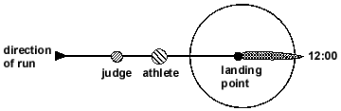  
A valid throw is when the small end of the caber passes through the vertical position and falls away from the competitor to land within the 180-degree radius between 9 o'clock and 3 o'clock. An overhead view is drawn below in Figure 2 to demonstrate some turned cabers and how to score them.

*Figure 2*  
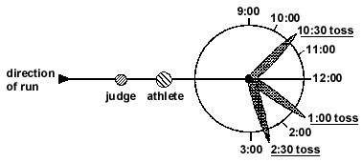  
If the caber lands in a 12 o'clock position pointing away from the competitor but not in a direct line with their run (as when a competitor turns to one side at the last step or two), then the judge must determine the **competitor's direction of run** and then look through the competitor to the small end of the caber, thus giving a true reading of its relation to the direction of run. The direction of run is determined by the direction in which the competitor runs after having control of the caber. An overhead view is drawn below in Figure 3 to demonstrate a toss such as this.

*Figure 3*  
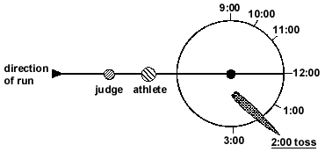

Once the competitor has started on his run, the judge should pick a point in the horizon to use as a reference point once the toss has been made. The competitor may run in one direction and then stop and change directions if they show control over the caber. The caber shall be judged on its initial landing position, not the position to which it may bounce or roll.  
If the caber is not turned by the competitor, then it is the responsibility of the side judge to determine the angle at which the caber was tossed with respect to the 90 degree vertical. The side judge should be perpendicular to the competitor's direction of run to make an accurate call. A drawing of a view from the side judge's position is shown below in Figure 4.

*Figure 4*  
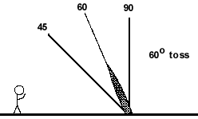

* **General Rules for Height Events**

1. Each competitor will be allowed three attempts at each height.
2. A competitor may pass any height they choose, but each height attempted must be cleared before attempting the next height. Once the competitor has entered the event, they may not skip subsequent heights.
3. When a competitor has missed three attempts at one height then they will be eliminated from the competition.
4. A competitor will not pass individual attempts without also leaving the competition.
5. All measurements will be made from the ground to the top of the crossbar.
6. The judge and/or Athletic Director will determine the opening heights with the Athletic Director having the final decision.
7. The bar shall be raised by larger increments until most of the competitors are eliminated and then may be raised by a lesser amount requested by the competitors and agreed to by the judge. Specific height requests from competitors will only be accepted once two competitors remain *and* agree, or on extra throws for event winners.
8. The crossbar may be suspended at both ends or by one end. It may be suspended at both ends by either pulleys and rope attached or rested on pegs attached to the uprights or both. If the implement pulls down the crossbar as it goes over, it is the judge's decision whether the toss will be counted or not. If the crossbar is suspended by resting on pegs ("touch-bar"), then the toss will not be counted if the crossbar is knocked off either peg. The crossbar will remain on the pegs after an attempt until the competitor leaves the throwing area (determined by the judge's discretion).
9. The crossbar will be 10'-0" in length or shorter.
10. The center of the implement will go over the bar within the inside of the uprights or the inside of the upright and the end of the bar if only one upright is used.
11. The implement may touch the crossbar as it goes over.
12. Ties will be broken by comparing the number of misses at the last height cleared. The competitor with the least number of misses at that height will place highest. If this number of misses are equal, then the next highest height is then compared and the competitor with the least number of misses at that height will place highest. If other ties occur, then this process is repeated for each previous height until all places are determined. **If a tie remains** after this process, the athlete with the fewest total throws wins the event.
13. The winner of the event may continue to throw at greater heights until they miss 3 attempts at one height. Once 3 misses at one height, no more attempts will be allowed, and the event will conclude.

* **Sheaf Toss**

The sheaf will be a burlap or plastic bag filled with a suitable material such as straw, mulch, or rope. The sheaf will be thrown, using a pitchfork, over a crossbar for height. The toss shall be made in any manner desired using a pitchfork with at least two tines. Weights for the sheaf bags are listed below.

Standard weight for *amateur, masters & lightweight men*: **16lbs or 20lbs.**

Standard weight for *professional men:* **20lbs.**

Standard weight for *amateur, masters, lightweight & professional women:* **10lbs or 12lbs**

* **Weight Over Bar/Weight For Height**

The weight will be thrown with one hand only. The weight shall be made of metal but can be of various shapes and sizes including spherical, bullet or box shaped. The handle can either be attached directly to the weight or attached with a length chain. The handle may also be of various shapes and thickness such as a ring, triangle or a "D" shape. The implement shall not measure more than 18" in overall length but a weight shorter than this is normally used when thrown for height to avoid hitting the ground when swung between the legs. Any throwing style may be used if the rules are followed, and the style is deemed safe by the judge and/or Athletic Director.  
  
Standard weight for *amateur & professional men*: **56lbs.**

Standard weight for *amateur & professional women:* **28lbs**.

Standard weight for *masters* & lightweight men:* **42lbs.**

Standard weight for *masters* & lightweight women:* **21lbs.**

*\*Masters over 60 may throw lighter implements as defined by Scottish Masters International.*

* **Judges**

Goin’ Rogue will make every effort to provide quality and professional judges at every competition. Judges must either be a long standing and recognized judge from another recognized organization *or* attend a judging clinic approved or hosted by Goin’ Rogue and shadow an established judge to show proficiency.

Judges will be provided a copy of the rule book well in advance of any competition. If a judge has any questions they are encouraged to check with the athletic director as soon as possible to seek clarification of the intent of the rule in question.

If any athlete has a question they may absolutely ask that judge to clarify as long as it is done in a polite and respectful way. Athletes are welcome to discuss judges and their decisions with the athletic director. This is not a means of undoing judging calls for simple fouls, marks, etc. We want to acknowledge legitimate concerns with professionalism and or knowledge of the rules, not squabbling over normal competition related happenings.

***Thank you,***

-Gerald Witzman and Chad Clark without whom I would not and could not, be doing any of this.

-Mat McDougal and countless others (you know who you are) for being a sounding board for my ridiculous ideas.

-Josh Mackintosh, Danny Webster, and Alex Duncan for being examples of great AD’ing within our sport and a source of inspiration and knowledge.

-And all of you for being a part of Goin’ Rogue and our little corner of this sport.

*-*Jeremy